CO2 ASSESSMENT TOOL – 2
Scenario-Based Requirement Analysis
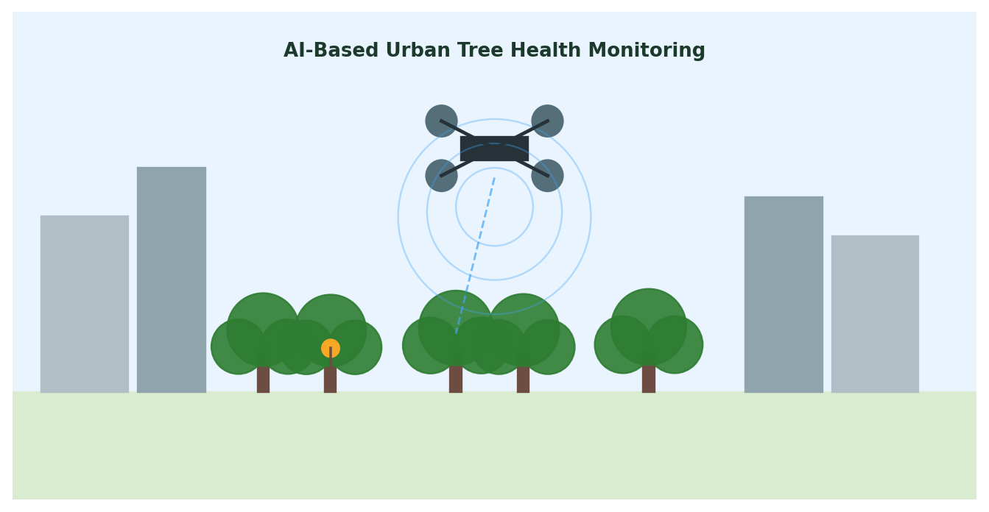

Smart AI-Based Urban Tree Health Monitoring and
Green Space Management System

Student Name | Divya Prashanth S
Register Number | 192521361
Course Code | CSA1017- Software Engineering
CO Assessed | CO2 AT2
Assessment | Assessment Tool 2 - Architecture design assignment

Rubrics for Calculation:
Evaluation Criteria | Excellent (4) | Good (3) | Satisfactory (2) | Needs Improvement (1)
System Requirement Analysis | Thorough analysis of problem, FR/NFR, and clear quality attribute explanation. | Analyzes most requirements, minor omissions. | Only basic requirements, partial analysis. | Incomplete, inaccurate, or unclear.
Selection of Software Architecture | Most appropriate style with strong technical justification. | Suitable architecture with reasonable justification. | Partially suitable, limited justification. | Inappropriate or unjustified.
Architecture Diagram & Component Design | Clear, complete, well-structured diagram with all components/interfaces. | Mostly complete, minor omissions/notation issues. | Only essential components, lacks detail. | Incomplete, unclear, or incorrect.
Component Interaction & Quality Attribute Analysis | Clearly explains responsibilities/interactions; thorough quality attribute discussion. | Explains most components/attributes, minor gaps. | Limited explanation, only some attributes addressed. | Poorly explained or missing.
Architectural Justification & Technical Presentation | Strong justification, trade-offs, future scope; professional report. | Adequate justification, minor gaps; well organized. | Limited justification, minimal trade-off discussion. | Weak/absent justification; poor organization.

Criteria | Mark
System Requirement Analysis | /5
Selection of Software Architecture | /5
Architecture Diagram and Component Design | /5
Component Interaction and Quality Attribute Analysis | /5
Architectural Justification and Technical Presentation | /5
TOTAL | /25

PROBLEM STATEMENT

24. Smart AI-Based Urban Tree Health Monitoring and Green Space Management System
- Industry Context
- Urban forests and green spaces play an important role in improving air quality, biodiversity, and climate resilience.
- Municipal authorities require intelligent systems to monitor tree health and
- manage urban vegetation efficiently.
- AI, drones, satellite imagery, GIS, and IoT sensors enable
- continuous environmental monitoring and predictive maintenance.
- Problem Statement.
- Urban trees are affected by diseases, pest infestations, pollution, and climate change, but manual inspections are infrequent and resource-intensive.
- This results in delayed interventions and declining
- green cover.
- An AI-powered urban tree monitoring platform should analyze drone imagery, monitor environmental conditions .
- detect tree diseases, assess growth patterns, and recommend maintenance activities.
- The system should support sustainable urban forestry management and
- environmental conservation.

1. System Requirement Analysis

1.1 System Objectives
The system must continuously observe urban tree health using aerial imagery and IoT sensors, apply AI to detect disease and abnormal growth, map trees geographically via GIS, and generate maintenance recommendations that support sustainable green-space management, aligned directly with the objectives in the problem statement.

1.2 Functional Requirements Influencing Architecture
- Ingesting and processing large volumes of drone/satellite imagery on a schedule.
- Running AI/ML inference for disease detection and growth-pattern analysis.
- Collecting continuous real-time telemetry from distributed IoT sensors.
- Maintaining and serving a GIS-based tree map to multiple client applications.
- Generating and delivering maintenance recommendations and alerts.
- Supporting citizen reporting and role-based staff dashboards concurrently.

1.3 Non-Functional Requirements & Quality Attributes
Quality Attribute | Why it matters here
Scalability | Must scale independently as sensor count, drone coverage, and city zones grow.
Maintainability | AI models and business rules need frequent, isolated updates without full redeployment.
Reliability | Sensor/network interruptions must not stop the whole platform from functioning.
Availability | Dashboards and citizen reporting must remain accessible with minimal downtime.
Performance | Imagery batches and sensor streams must be processed within defined time targets.
Security | Sensitive location and citizen data must be protected with access control and encryption.

2. Selection of Software Architecture

2.1 Selected Architecture: Microservices with an Event-Driven Backbone
A hybrid Microservices Architecture, using an event-driven message broker for asynchronous communication between services, is selected for this system.

2.2 Justification
- Independent scalability: AI disease-detection inference is far more compute-intensive than, say, user management, so each capability must scale on its own rather than as one monolith.
- Independent deployment: AI/ML models are retrained and redeployed frequently; microservices allow this without touching unrelated services such as notifications or GIS mapping.
- Heterogeneous, asynchronous data sources: drones, IoT sensors, and citizen reports arrive at different rates and formats; an event-driven backbone (message broker) decouples producers from consumers and absorbs bursty imagery/sensor loads.
- Fault isolation: a failure in one service (e.g., growth-analysis) does not bring down GIS mapping or citizen reporting, directly supporting the Reliability and Availability requirements.
- Alignment with municipal integration needs: services expose APIs through a gateway, simplifying integration with existing municipal GIS and asset-management systems.
Alternative styles considered: a pure Layered/monolithic architecture was rejected because AI workloads and lightweight services would be forced to scale together, wasting resources; a purely Serverless approach was considered but a hybrid with core stateful services (GIS registry, model store) fits municipal on-premise/cloud constraints better.

3. Software Architecture Diagram
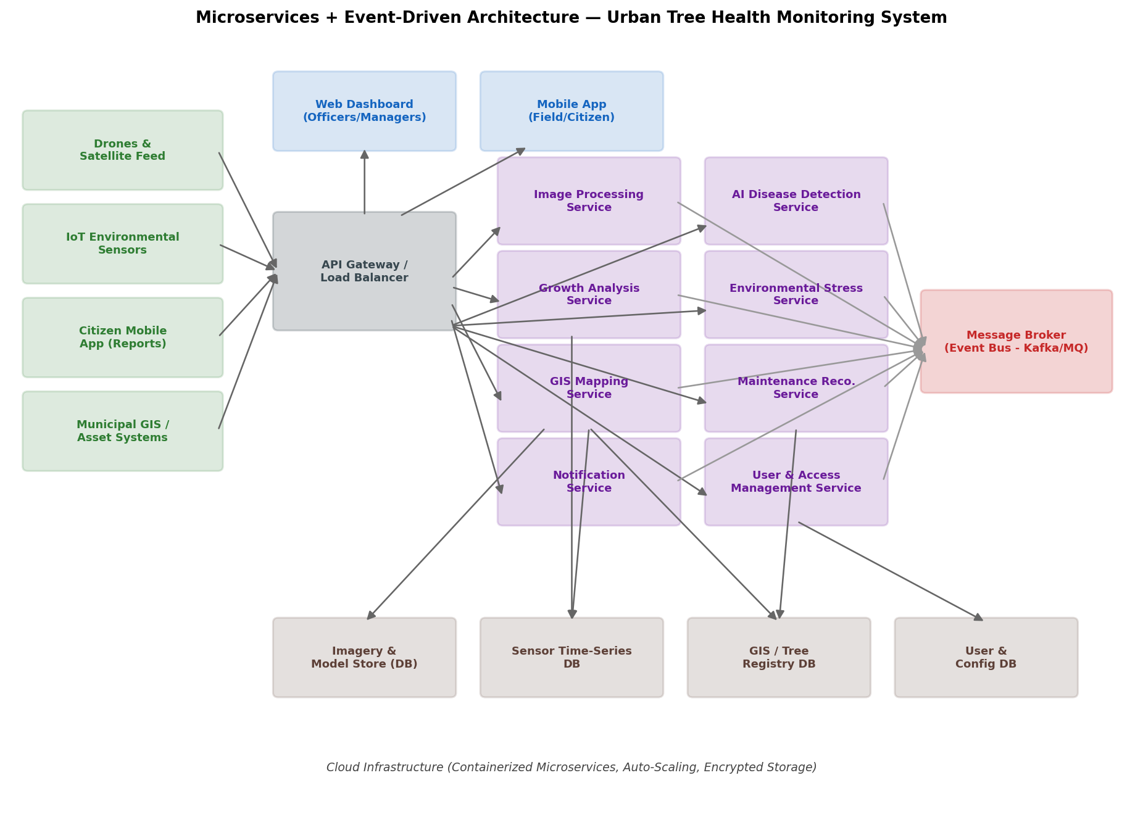
The diagram shows external data sources on the left, an API Gateway/Load Balancer, the presentation layer (web dashboard, mobile app), the microservices layer, a central message broker for event-driven communication, and dedicated databases per service domain, all hosted on containerized, auto-scaling cloud infrastructure.

4. Components and Their Interactions
Component | Responsibility
API Gateway / Load Balancer | Single entry point; routes requests, handles authentication, and balances load across service instances.
Image Processing Service | Receives drone/satellite imagery, performs preprocessing (tiling, normalization) before AI analysis.
AI Disease Detection Service | Runs ML inference to classify disease/pest symptoms from processed imagery.
Growth Analysis Service | Compares canopy imagery across time to compute growth trend metrics.
Environmental Stress Service | Correlates IoT sensor readings (soil, air, temperature) with tree health indicators.
GIS Mapping Service | Maintains and serves the geographic tree registry and health-status map layers.
Maintenance Recommendation Service | Combines AI and environmental outputs to rank and generate maintenance actions.
Notification Service | Delivers alerts to field staff, managers, and citizens through push/SMS/email.
User & Access Management Service | Handles authentication, roles, and permissions for all user types.
Message Broker (Event Bus) | Decouples services; publishes/subscribes events such as "DiseaseDetected" or "SensorAlert" for asynchronous processing.
Databases (per service) | Domain-specific stores: imagery/model store, sensor time-series DB, GIS/tree registry DB, user/config DB - avoiding tight coupling on a shared schema.

4.1 Overall Workflow
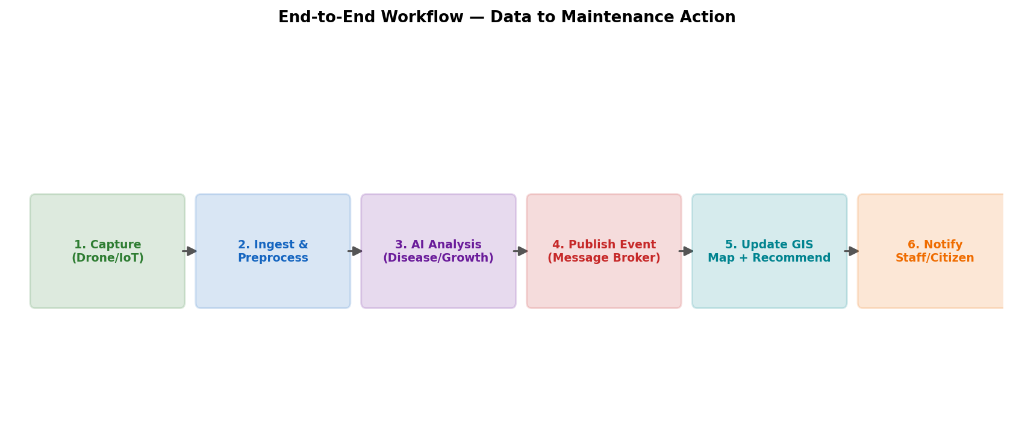
Data flows from capture through preprocessing, AI analysis, event publication, GIS/recommendation update, and finally notification - each stage handled by an independent service communicating through the message broker and API gateway.

5. Discussion of Quality Attributes
Attribute | How the Architecture Addresses It
Scalability | Each microservice (e.g., AI Disease Detection) can be scaled horizontally and independently based on load, using container orchestration and auto-scaling policies, without over-provisioning lightweight services.
Security | The API Gateway centralizes authentication/authorization; role-based access control at the User & Access Management Service restricts data by stakeholder type; data is encrypted in transit (HTTPS) and at rest.
Performance | Asynchronous event-driven processing via the message broker prevents slow AI inference from blocking imagery ingestion or dashboard responsiveness; caching can be applied at the GIS Mapping Service for frequently viewed map tiles.
Reliability | Service isolation ensures a failure in one microservice (e.g., Growth Analysis) does not cascade; the message broker buffers events during transient service outages, supporting eventual processing.
Maintainability | Independent deployment pipelines let the AI/ML model in the Disease Detection Service be retrained and redeployed without modifying or redeploying other services.
Availability | Redundant service instances behind the load balancer, combined with database replication per domain, keep dashboards and citizen reporting available during partial outages.

6. Justification of Architectural Decisions

6.1 Rationale
The core decision - splitting the platform into domain-aligned microservices connected through an event bus - directly follows from the differing scaling, update frequency, and failure-isolation needs identified in Section 1. Compute-heavy AI services, lightweight CRUD-style services (user management), and high-throughput ingestion services (image/sensor processing) each have very different resource profiles that a single monolith would handle inefficiently.

6.2 Trade-offs Considered
- Increased operational complexity (service discovery, monitoring, distributed tracing) was accepted in exchange for independent scalability and fault isolation.
- Eventual consistency between services (e.g., a slight delay between AI detection and dashboard update) was accepted over strict consistency, since near-real-time (not instant) updates are acceptable for tree health monitoring.
- A message broker adds infrastructure overhead but was chosen over direct service-to-service calls to avoid tight coupling and to handle bursty drone/sensor data gracefully.

6.3 Support for Future Enhancements and Long-Term Maintainability
- New capabilities (e.g., a biodiversity-tracking service or a carbon-sequestration estimator) can be added as new microservices without modifying existing ones.
- The API Gateway allows new client applications (e.g., a public transparency portal) to be integrated without changing backend services.
- AI models can be upgraded or A/B tested within the Disease Detection Service independently of the rest of the platform.
- Standardized APIs and event schemas make it straightforward to integrate additional municipal systems or third-party environmental data providers over time.

7. Conclusion
The proposed Microservices architecture with an event-driven backbone directly addresses the scalability, reliability, maintainability, availability, performance, and security needs of an AI-based urban tree monitoring platform. By isolating compute-intensive AI workloads, decoupling data producers and consumers through a message broker, and organizing storage per service domain, the design supports the system's current objectives while remaining flexible for future enhancements and long-term operation.

